Sample invocation after all the components below are started

1. Discovery service
2. Gateway service
3. Products Service
4. Inventory Service
5. Order Service

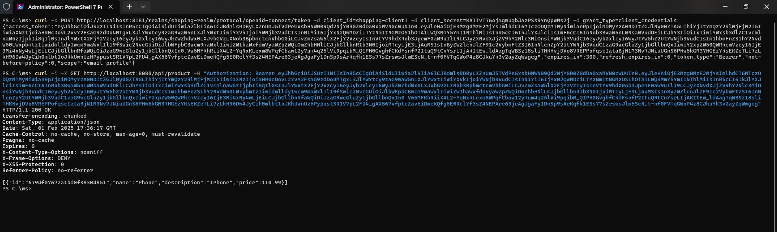

Invocation: curl 🡪 gateway 🡪 order 🡪 database

Below is the circuit breaker implementation health check

In below screenshots we will fire the ‘order-service’ post method as well. In this case, upon firing the order service there will be a call made to ‘inventory service as well’. In the next step we will try to **stop** the inventory service so that circuit breaker kicks-in.

Notice the eureka server that has one instance for ‘inventory-service’ up

We stopped

After shutting down the inventory service, made 5 calls to place the order. Notice that the state is now turned to ‘HALF_OPENED’

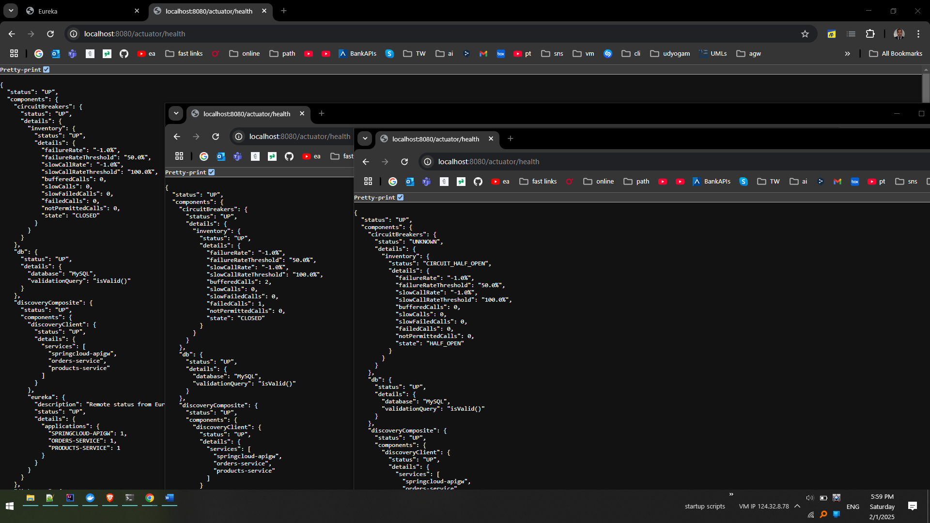

This state means that the destination service is down and no longer able to be reached.

Next step is to restart the inventory service and fire multiple calls like atleast 5. Post that notice the health it is not changed to ‘closed’ Meaning, the destination is up.

